Data Sources:

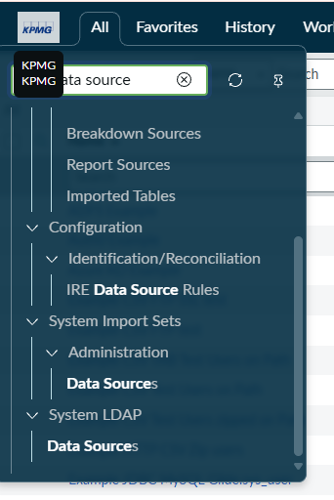
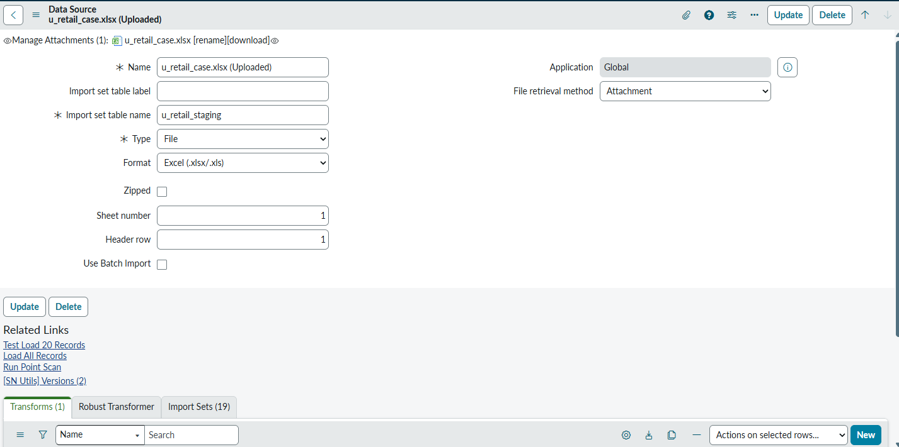

sys_data_source

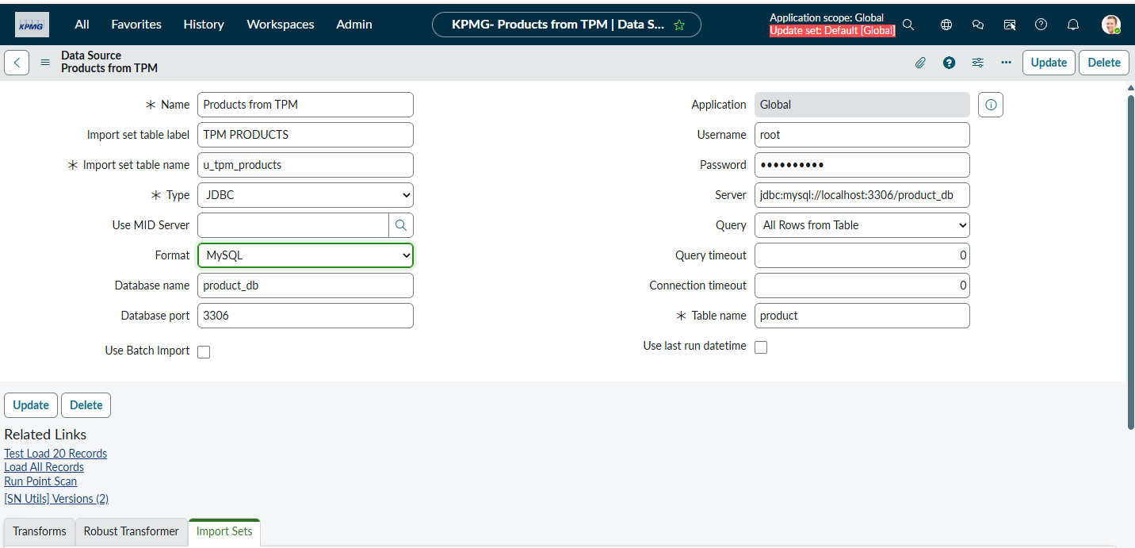
To connect PDI to local MySQL we need to install MID server

LDAP->
LDAP : Light Weight Active Directory protocol

To bring more options below
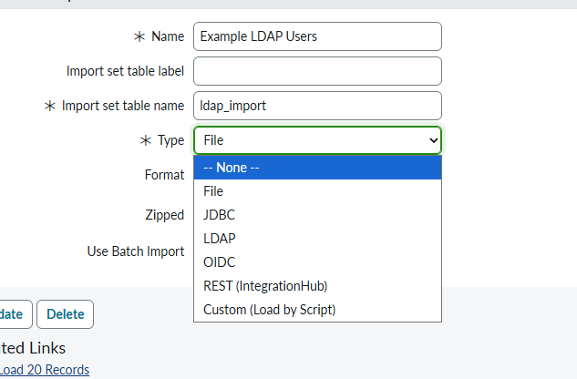
we can install plugins

